**On Demand Traffic light Documentation**

Table of content

1. System description
2. System design
3. System flow chart
4. System constraints
5. System description:

It is an on demand traffic light system. Normally allowing cars to pass, get ready, stops and so on, on 5 Seconds intervals. While an on demand mode for pedestrians can be activated to allow the pedestrians to pass the road safely by giving them the priority to pass instead of the cars.

1. System design
2. The system design is divided into hardware and software.
3. The Hardware components of the system as shown in fig no.1 are:
4. Avr Atmega 32 (1MHZ)
5. 2 Green LEDS
6. 2 Yellow LEDS
7. 2 RED LEDS
8. 6 no. 300 ohm Resistors
9. 1 no. 10K ohm Resistor.
10. 1 no. push button.

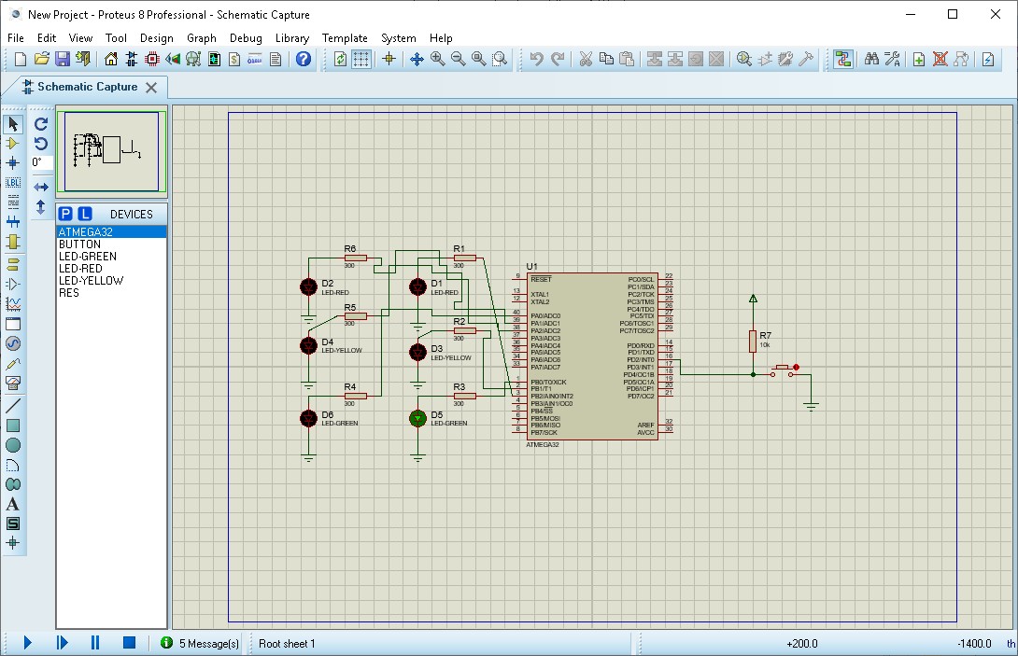

Fig.no.1: Hardware System overview

1. The Software consists of a number of layers as show in fig 2 each layer contains a number of drivers in addition to the utilities that contains the software own libraries.

The software layers are :

1-The MCal layer: the dio , timers, and interrupt drivers.

2-ECUAL Layer: LED driver and Button driver.

3-Application Layer: logic of the normal and pedestrian mode.

4-Utilities: Types and registers header files.

Application Layer

ECUAL

LED Driver, Button driver

MCAL

DIO, interrupt and Timer driver

Microcontroller

Fig 2: software components

1. System flow chart

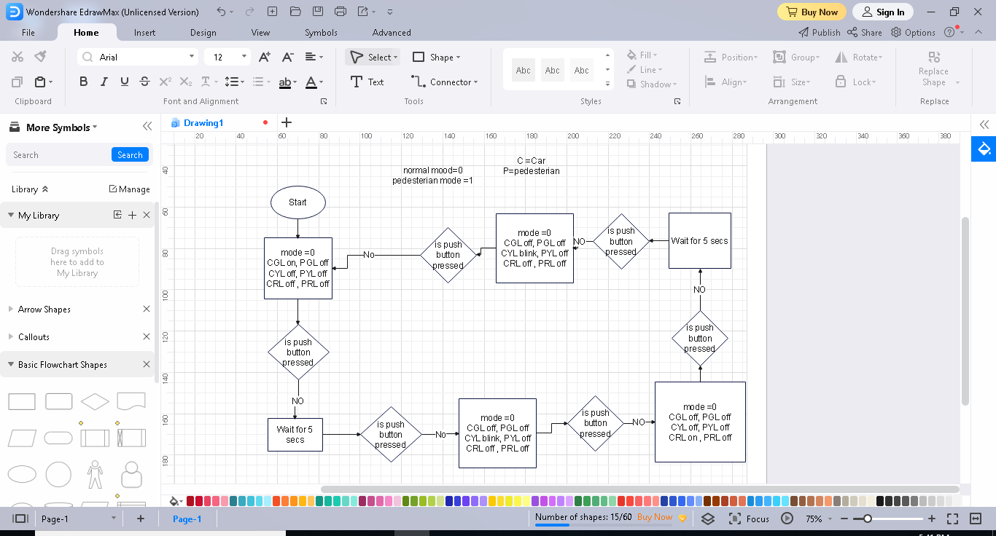

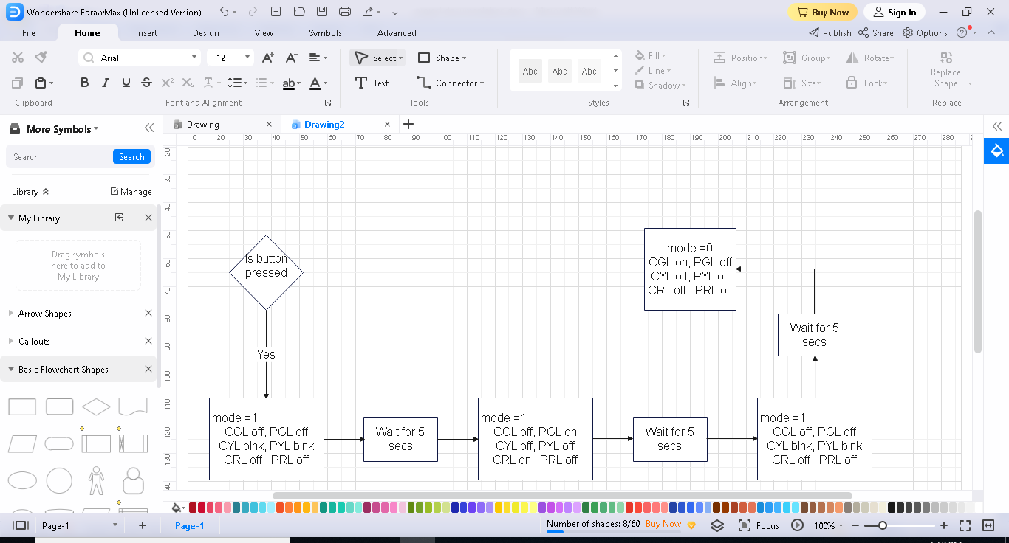

1. System constraints

* The systems works normally in normal mode which mean starts the car traffic light in green then yellow blinking then red then yellow blinking again then again to green in 5 secs intervals unless the bush button is pressed the system will enter the pedestrian mode and will start double blinking of both yellow leds then turn the green led of pedestrian on and the red led of cars on then turn the green led of pedestrian off and the red led of cars off turn and start double blinking of both yellow leds in 5 secs intervals then start normal mode again.
* Entering the pedestrian mode is through short or long press. While double press does not apply any changes to the system.